#
# 20200302
#
https://www.veritas.com/

# Choose “Support”.
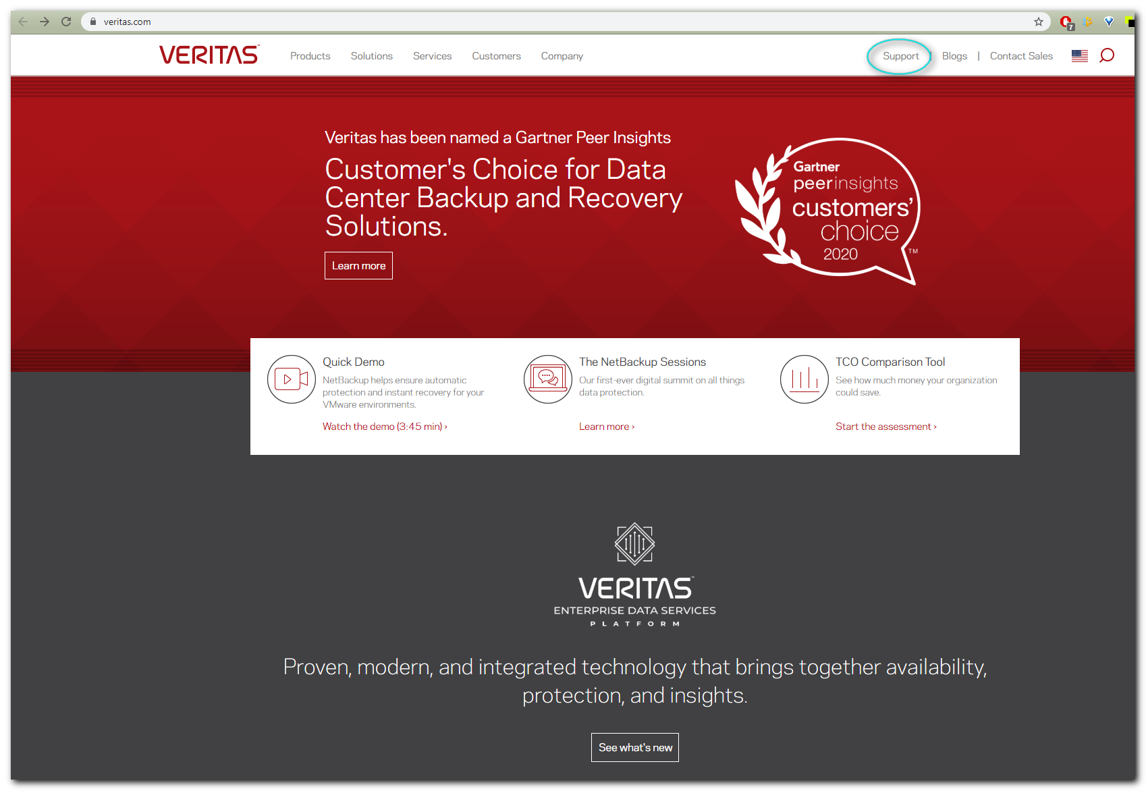

#
# Then login with a picture in right up conner.

# This account used to login to Veritas support.
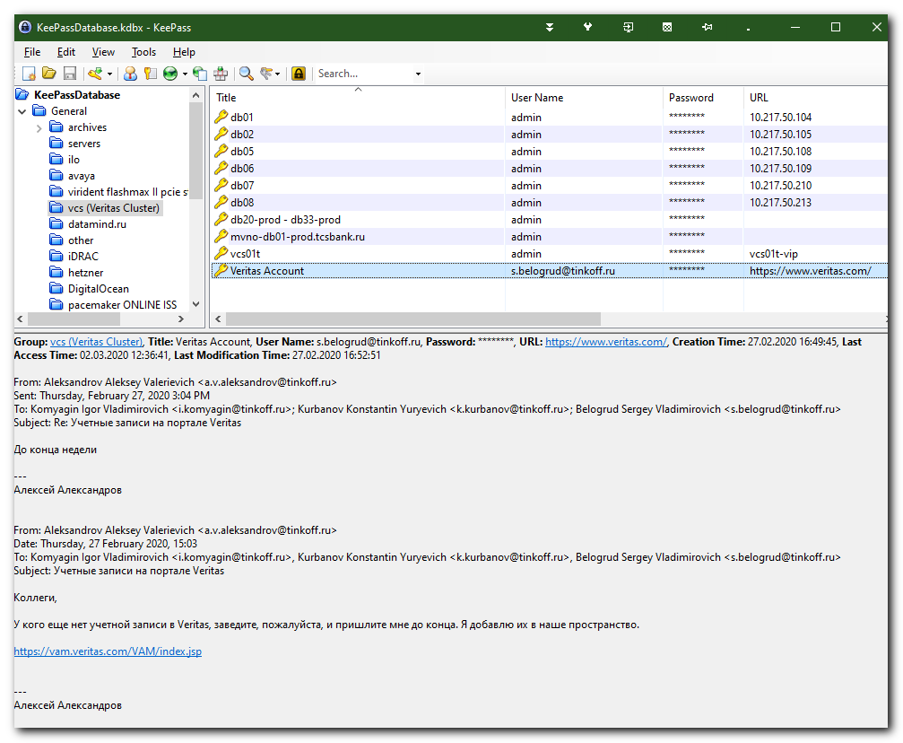

#
# After successful login, choose “My cases”.
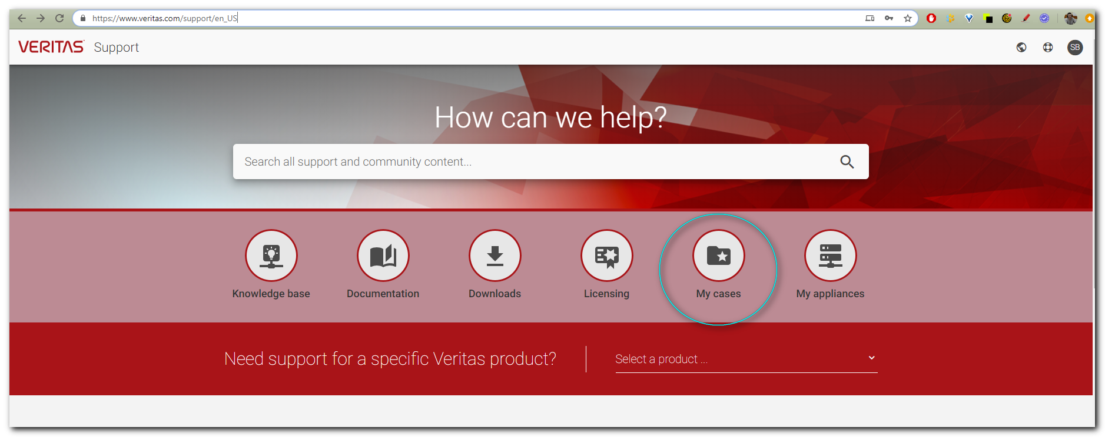

#
# Here it’s need to choose appropriate filter: “My company’s cases”.
